**JSF 2 : AJAX SUPPORT**

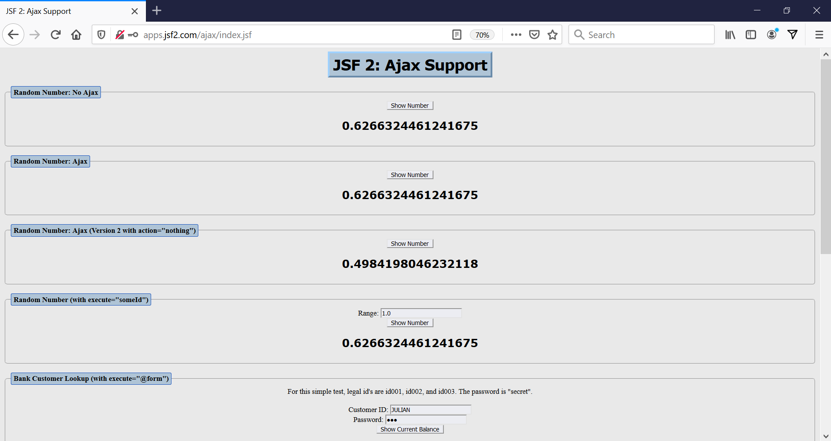

**AJAX EXERCISES**

